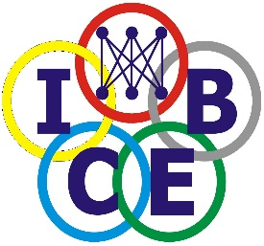
The 19th International Conference on Electronic Business (ICEB 2019)
Northumbria University,
Newcastle Upon Tyne, United Kingdom, 8-12 December 2019

Last Opportunity for PhD and master student Participation in ICEB2019!

Local UK PhD or Master Students are given opportunities to present their papers in ICEB for £100. This last opportunity gives Local PhD or master students opportunities to present their work, either initial research ideas or preliminary research findings at the ICEB special PhD workshop.

If you are not presenting but simply participate in the conference, you can still register with £100 to participate in the conference and enjoy the full session of the conference.

The registration will also give PhD and master students to access the full conference sessions including open reception, tea break, lunch, and dinners.

You are encouraged to submit a minimum one page abstract for the presentation of your paper.

Online submission: https://easychair.org/conferences/?conf=iceb2019
Conference website: http://iceb2019.johogo.com
Online registration: https://store.northumbria.ac.uk/conferences-and-events/campus-services/academic-conference/19th-international-conference-on-electronic-business

ORGANIZERS:
International Consortium for Electronic Business, USA
Department of Computer and Information Sciences, Faculty of Engineering and Environment, Northumbria University, Newcastle Upon Tyne, United Kingdom

CONFERENCE CHAIR:
Dr. Honglei Li, Department of Computer & Information Sciences, University of Northumbria at Newcastle, Newcastle upon Tyne, United Kingdom
CONFERENCE CO-CHAIRS:
Professor Savvas Papagiannidis, Newcastle University, Newcastle Upon Tyne, United Kingdom
Dr. Zhibin Lin, Durham University, Durham, United Kingdom
LOCAL ARRANGEMENT CO-CHAIR:
Dr. Shan Shan, Northumbria University, Newcastle upon Tyne, United Kingdom
Contact Shan.Shan@northumbria.ac.uk for more details.

